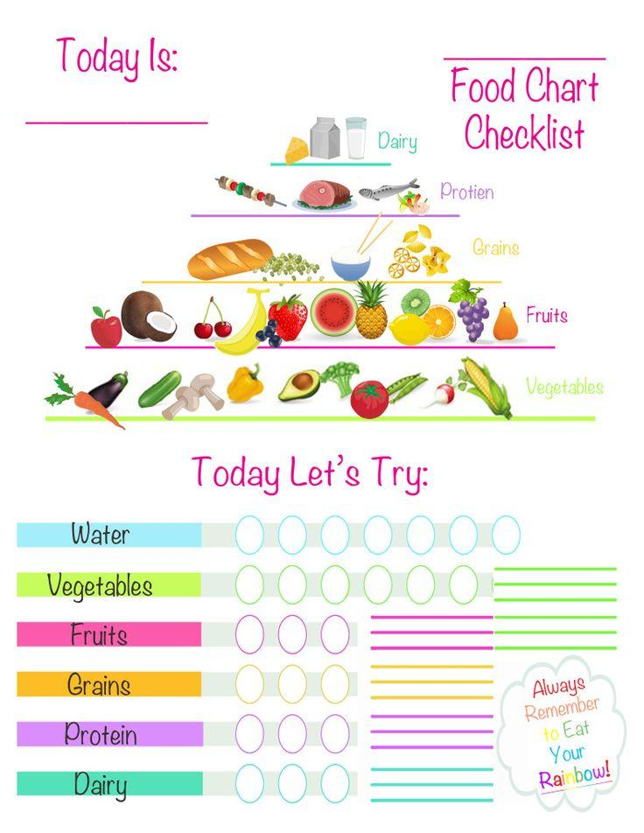

Tracker found here: <https://www.pinterest.com.au/amp/pin/407012885051990437/>

Credit: Tidy Lady